Name - Sahil Sagar Badoni

University Roll no. – 1922054

Course-B.Sc IT 5th Sem

**Q1.** Develop an android application to demonstrate Implicit Explicit.

activity_main.xml

*<?***xml version="1.0" encoding="utf-8"***?>*<**androidx.constraintlayout.widget.ConstraintLayout xmlns:android="http://schemas.android.com/apk/res/android"  
 xmlns:app="http://schemas.android.com/apk/res-auto"  
 xmlns:tools="http://schemas.android.com/tools"  
 android:layout_width="match_parent"  
 android:layout_height="match_parent"  
 android:onClick="openActivity"  
 tools:context=".MainActivity"**>  
  
 <**EditText  
 android:id="@+id/name"  
 android:layout_width="wrap_content"  
 android:layout_height="wrap_content"  
 android:ems="10"  
 android:inputType="textPersonName"  
 android:minHeight="48dp"  
 android:text="Name"  
 app:layout_constraintBottom_toBottomOf="parent"  
 app:layout_constraintEnd_toEndOf="parent"  
 app:layout_constraintHorizontal_bias="0.393"  
 app:layout_constraintStart_toStartOf="parent"  
 app:layout_constraintTop_toTopOf="parent"  
 app:layout_constraintVertical_bias="0.176"  
 tools:ignore="TouchTargetSizeCheck,TouchTargetSizeCheck"** />  
  
 <**Button  
 android:id="@+id/button"  
 android:layout_width="wrap_content"  
 android:layout_height="wrap_content"  
 android:onClick="openActivity"  
 android:text="Button"  
 app:layout_constraintBottom_toBottomOf="parent"  
 app:layout_constraintEnd_toEndOf="parent"  
 app:layout_constraintHorizontal_bias="0.425"  
 app:layout_constraintStart_toStartOf="parent"  
 app:layout_constraintTop_toBottomOf="@+id/name"  
 app:layout_constraintVertical_bias="0.336"** />  
</**androidx.constraintlayout.widget.ConstraintLayout**>

Activity_main_2.xml:-

*<?***xml version="1.0" encoding="utf-8"***?>*<**androidx.constraintlayout.widget.ConstraintLayout xmlns:android="http://schemas.android.com/apk/res/android"  
 xmlns:app="http://schemas.android.com/apk/res-auto"  
 xmlns:tools="http://schemas.android.com/tools"  
 android:layout_width="match_parent"  
 android:layout_height="match_parent"  
 tools:context=".MainActivity2"**>  
  
 <**TextView  
 android:id="@+id/textView"  
 android:layout_width="wrap_content"  
 android:layout_height="wrap_content"  
 app:layout_constraintBottom_toBottomOf="parent"  
 app:layout_constraintEnd_toEndOf="parent"  
 app:layout_constraintStart_toStartOf="parent"  
 app:layout_constraintTop_toTopOf="parent"** />  
</**androidx.constraintlayout.widget.ConstraintLayout**>

MainActivity.java:-

**package** com.example.intentsahilsagarbadoni;  
  
**import** androidx.appcompat.app.AppCompatActivity;  
  
**import** android.content.Intent;  
**import** android.os.Bundle;  
**import** android.view.View;  
**import** android.widget.Button;  
**import** android.widget.EditText;  
**import** android.widget.Toast;  
  
**public class** MainActivity **extends** AppCompatActivity {  
EditText **name**;  
Button **b**;  
**public static final** String ***Extra_Name*** =**"com.example.intentsahilsagarbadoni.extra.Name"**;  
 @Override  
 **protected void** onCreate(Bundle savedInstanceState) {  
 **super**.onCreate(savedInstanceState);  
 setContentView(R.layout.***activity_main***);  
 **name** = (EditText) findViewById(R.id.***name***);  
 **b**= (Button ) findViewById(R.id.***button***);  
 }  
 **public void** openActivity(View v) {  
 Toast.*makeText*(**this**, **"Opening Second Activity"**, Toast.***LENGTH_SHORT***).show();  
 Intent intent = **new** Intent(**this**, MainActivity2.**class**);  
 String nameText = **name**.getText().toString();  
 Intent intent = intent.putExtra(***Extra_Name***, nameText);  
 startActivity(intent);  
 }  
}

mainactivity2.java:-

**package** com.example.intentsahilsagarbadoni;  
  
**import** androidx.appcompat.app.AppCompatActivity;  
  
**import** android.content.Intent;  
**import** android.os.Bundle;  
**import** android.widget.EditText;  
**import** android.widget.TextView;  
  
**public class** MainActivity2 **extends** AppCompatActivity {  
TextView **textView**;  
 @Override  
 **protected void** onCreate(Bundle savedInstanceState) {  
  
 **super**.onCreate(savedInstanceState);  
 setContentView(R.layout.***activity_main2***);  
 **textView**=(TextView)findViewById(R.id.***textView***);  
 Intent intent=getIntent();  
 String name=intent.getStringExtra(MainActivity.***Extra_Name***);  
 **textView**.setText(**"Your name is"** +name);  
 }  
}

Output:-

Explicit

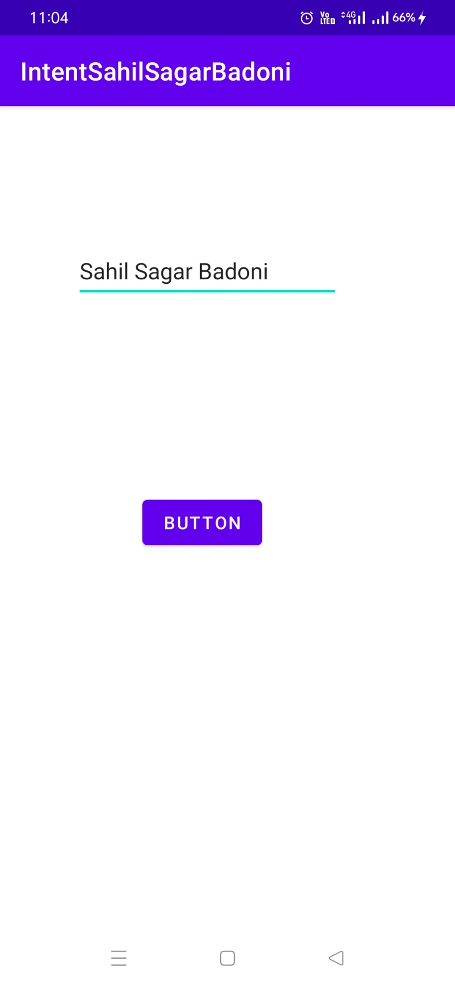

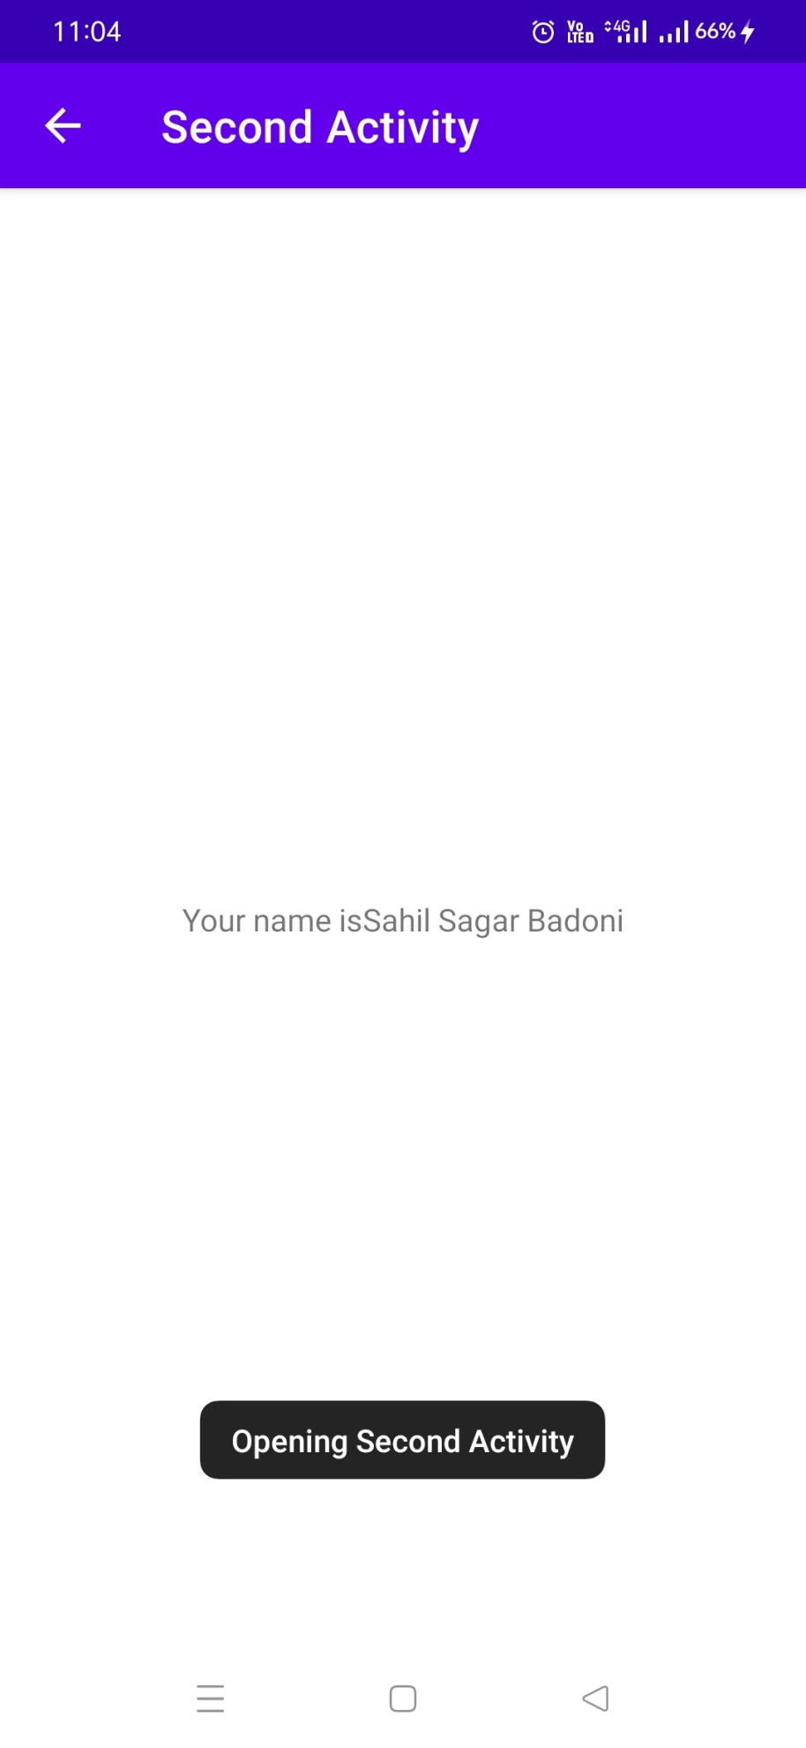

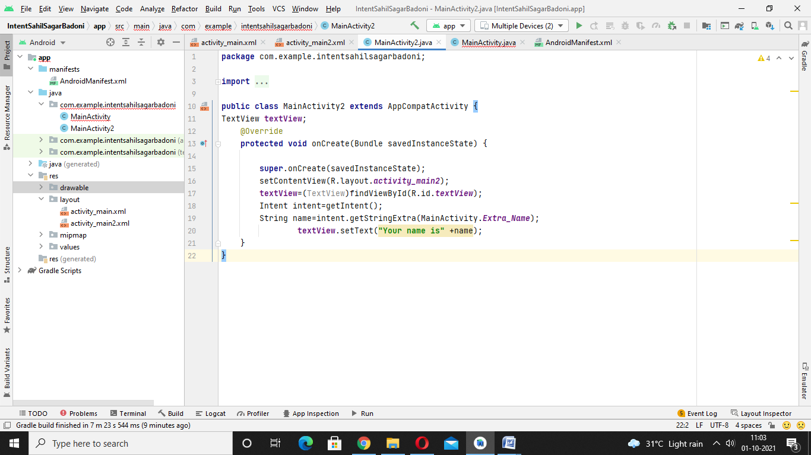

For implicit:-

**<?xml** version="1.0" encoding="utf-8"**?>**

**<android.support.constraint.ConstraintLayout** xmlns:android="http://schemas.android.com/apk/res/android"

    xmlns:app="http://schemas.android.com/apk/res-auto"

    xmlns:tools="http://schemas.android.com/tools"

    android:layout_width="match_parent"

    android:layout_height="match_parent"

    tools:context="example.javatpoint.com.implicitintent.MainActivity"**>**

**<EditText**

        android:id="@+id/editText"

        android:layout_width="wrap_content"

        android:layout_height="wrap_content"

        android:layout_marginEnd="8dp"

        android:layout_marginStart="8dp"

        android:layout_marginTop="60dp"

        android:ems="10"

        app:layout_constraintEnd_toEndOf="parent"

        app:layout_constraintHorizontal_bias="0.575"

        app:layout_constraintStart_toStartOf="parent"

        app:layout_constraintTop_toTopOf="parent" **/>**

**<Button**

        android:id="@+id/button"

        android:layout_width="wrap_content"

        android:layout_height="wrap_content"

        android:layout_marginRight="8dp"

        android:layout_marginLeft="156dp"

        android:layout_marginTop="172dp"

        android:text="Visit"

        app:layout_constraintEnd_toEndOf="parent"

        app:layout_constraintHorizontal_bias="0.0"

        app:layout_constraintStart_toStartOf="parent"

        app:layout_constraintTop_toBottomOf="@+id/editText" **/>**

**</android.support.constraint.ConstraintLayout>**

*MainActivity.java*

**package** example.javatpoint.com.implicitintentSahil;

**import** android.content.Intent;

**import** android.net.Uri;

**import** android.support.v7.app.AppCompatActivity;

**import** android.os.Bundle;

**import** android.view.View;

**import** android.widget.Button;

**import** android.widget.EditText;

**public** **class** MainActivity **extends** AppCompatActivity {

    Button button;

    EditText editText;

    @Override

**protected** **void** onCreate(Bundle savedInstanceState) {

**super**.onCreate(savedInstanceState);

        setContentView(R.layout.activity_main);

        button = findViewById(R.id.button);

        editText =  findViewById(R.id.editText);

        button.setOnClickListener(**new** View.OnClickListener() {

            @Override

**public** **void** onClick(View view) {

                String url=editText.getText().toString();

                Intent intent=**new** Intent(Intent.ACTION_VIEW, Uri.parse(url));

                startActivity(intent);

            }

        });

    }

}

Output:-